Low Vision Clinic...
What is it? Who Needs it?
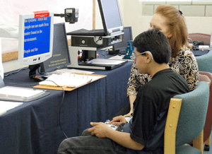
Students who have a reduced level of visual functioning that interferes with their educational and day-to-day activities are sometimes referred to as having low vision.
A large percentage of students who have been identified as having a visual impairment have some degree of useable vision. Many types of low vision devices and aids are available, as well as programming information that may assist these students in using the vision they have more efficiently.
Low Vision Clinic offers a special examination to determine if a student's visual abilities can be improved. At the Low Vision Clinic, a doctor of optometry who has received specialized training in working with children with visual impairments will measure how well the student sees things that are close and things that are distant, and will determine whether any low vision devices will help the student.
If a near or distance low vision device is recommended, the student will have additional opportunity to explore using the device(s) with the guidance of members of the Low Vision Clinic Team there at the appointment.
Low Vision examinations are provided through the NMSBVI Access to Learning Low Vision Services program at no cost to parents or school districts. Students from birth through age 21 are eligible for referral to a Low Vision Clinic.
The length of the Low Vision Clinic visit will vary greatly, depending on the age of the student and individual needs, as well as the extent of follow-up trial with devices provided. Low Vision Clinic visits can last from one hour to three hours.
The results of the Low Vision Clinic should be included as an essential component in the process of identifying the needs of students who have low vision.
Parents and the student's teacher for students who are visually impaired (TVI) are encouraged to participate throughout the clinic process and to accompany the student to the clinic.
A summary report of findings will be sent to the student's parents and the student’s TVI. Follow-up services will be planned as appropriate.
For additional information about the Low Vision Clinic or Low Vision Services, please contact:
Margaret Hidalgo
Low Vision Clinic Consultant
Cell: 575-415-6044
Fax: 505-271-3073
margarethidalgo@nmsbvi.k12.nm.us

Or:
Angela Harris
Outreach Dept. Administrative Assistant
Phone: 575-439-4431
Fax: 575-439-4454
angelaharris@nmsbv.k12.nm.us

